

1.)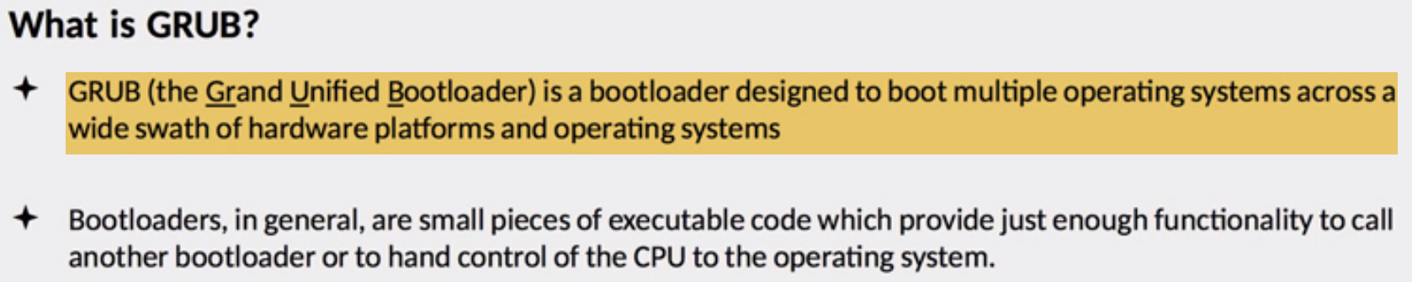 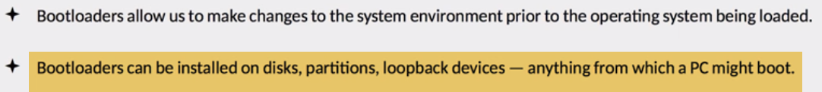

2.) 

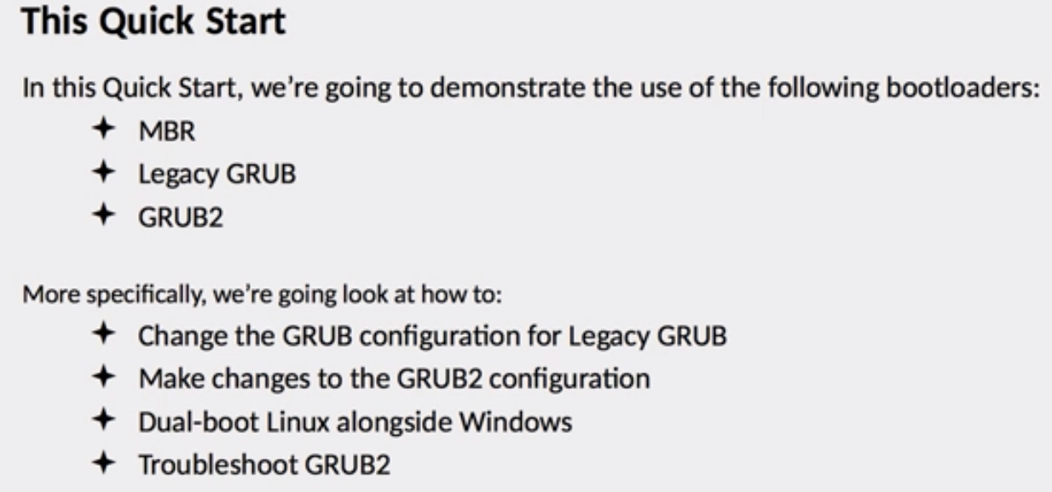

3.) 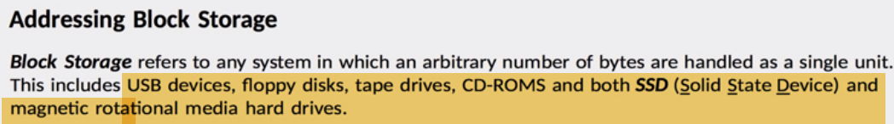 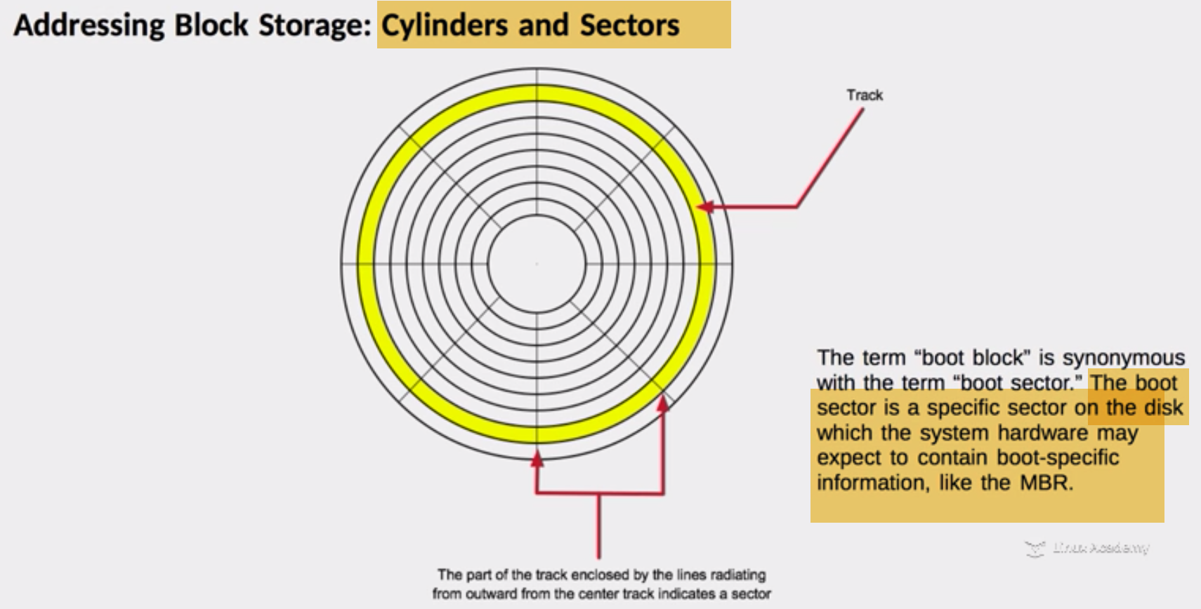

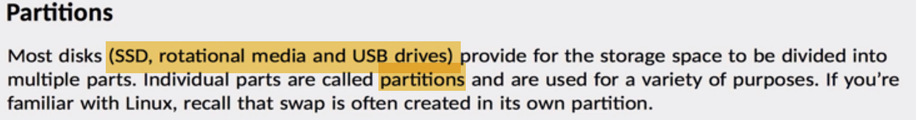 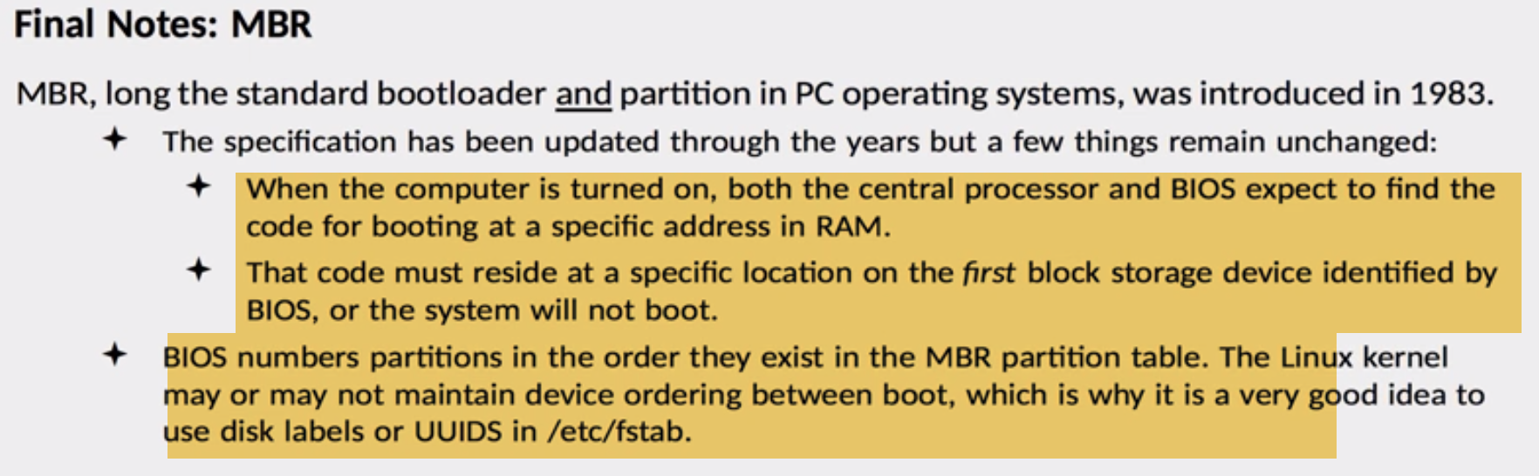 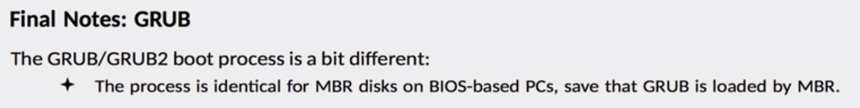

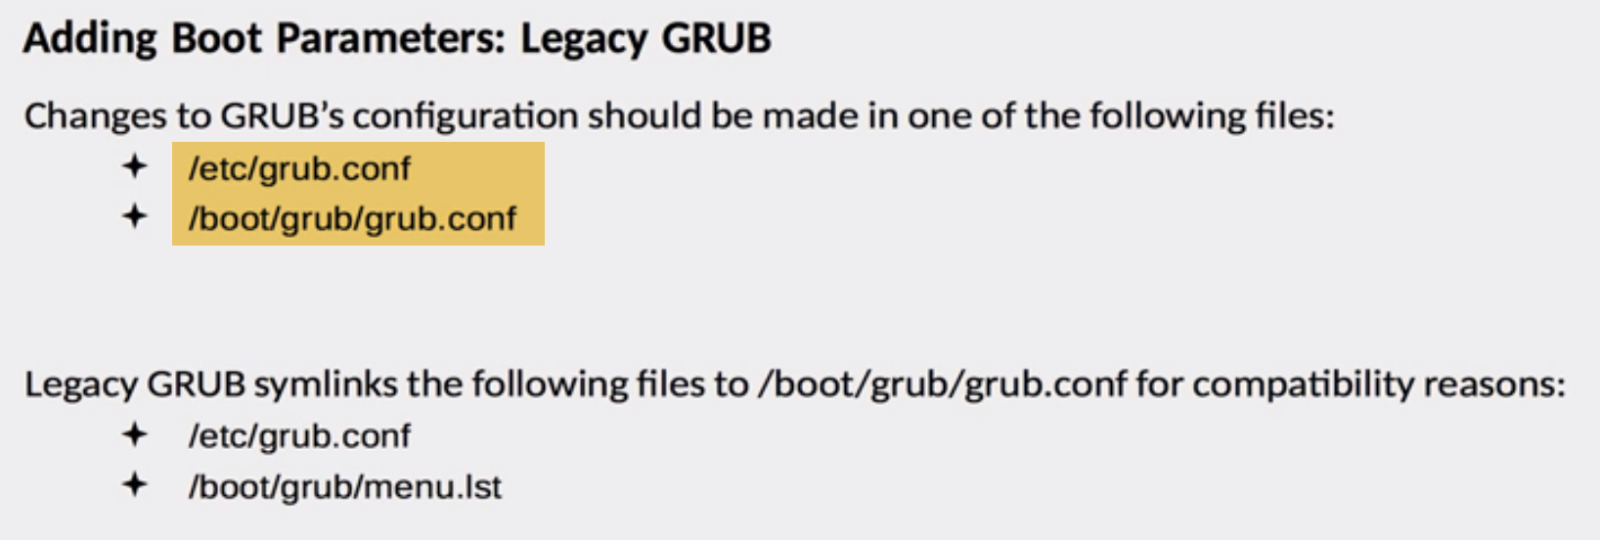 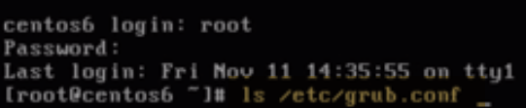 

Make changes🡪effected at next rebooted

Take latest kernal(updated): default=0 in list provided at booting

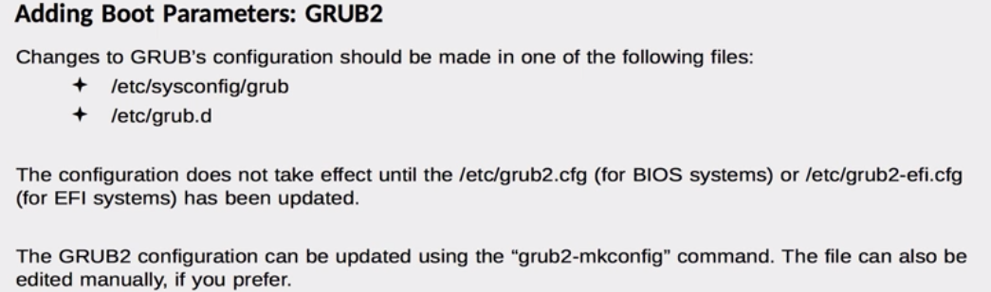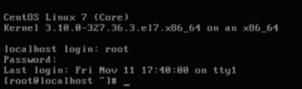**CentOS7 by default uses grub2...**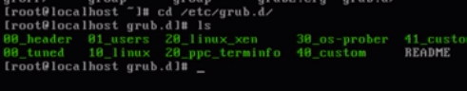

**-🡪** 

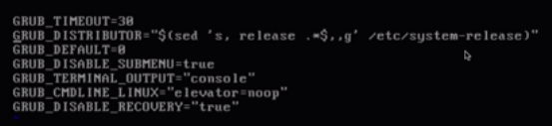

Here we define variables that are required to build grub configuration.

IN Legacy Grub: Make changes🡪effected at next rebooted

Here: Mkconfig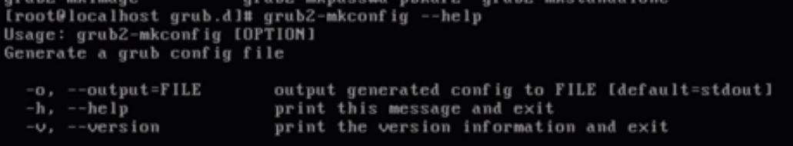

Now, we rebuild our grub-config making changes and reboot

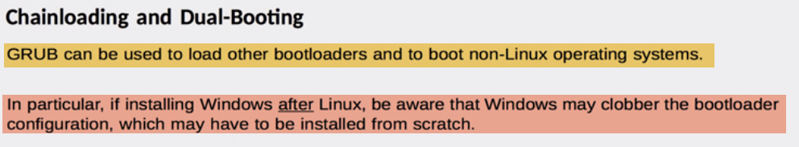 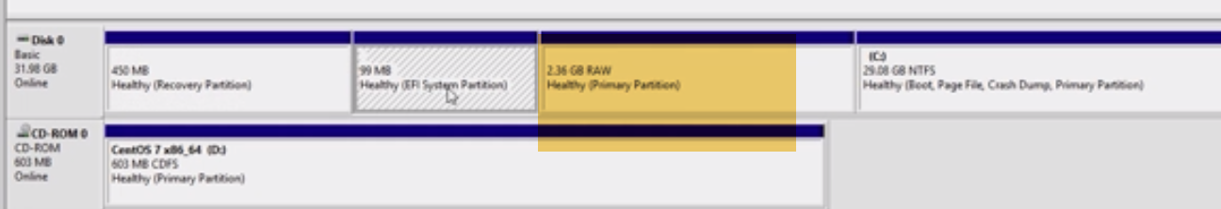

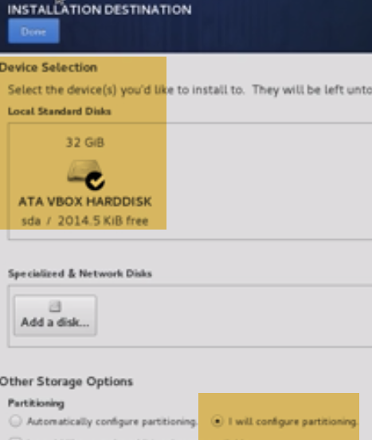 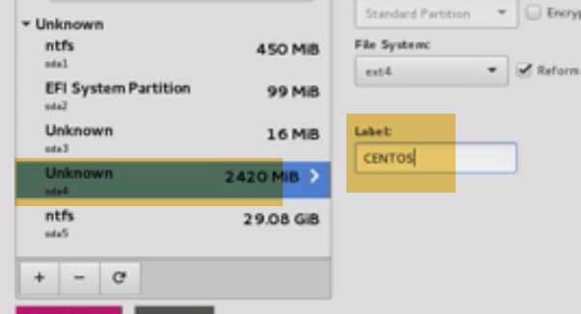

**Here Unkonwn is raw partition.Make label**